Gnanadeepam: Integrating Machine Translation and AI for Inclusive Multilingual Learning in Rural Kerala”

Kannikha H
School of Computer Science and Engineering Presidency University
Email: kannikha.20221cai0028@presidencyuniversity.in

Shrujanya M
School of Computer Science and Engineering Presidency University
Email: shrujanya.20221cai0039@presidencyuniversity.com

Rishabh Reddy G C
School of Computer Science and Engineering Presidency University
Email: rishabh.20221cai0032@presidencyuniversity.in

Dr. Swati Sharma
Professor, School of Computer Science and Engineering Presidency University
Email: swati.sharma@presidencyuniversity.in

Abstract— Even though Kerala is the most literate state in India, many rural areas still face significant hurdles in accessing digital education. Factors such as language barriers, poor internet connectivity, limited device availability, and a lack of educational resources all inhibit students' ability to effectively learn online. To help with this, we developed Gnanadeepam, a bilingual educational platform that uses both Malayalam and English. It is designed especially for students in grades 8 to 12, aiming to make learning easier and more engaging for them. Gnanadeepam offers personalized study plans that adapt to each student’s progress, an AI assistant that supports learning, and works well even without continuous internet access. The platform also focuses on local content relevant to the students’ environment and culture. Our study explains how the system was set up, describes its main features and modules, and looks at how it influenced student engagement and learning outcomes during testing. We also discuss the strengths of the platform, as well as the challenges we encountered, and share ideas for expanding its use to help more students in the future.
Keywords—Bilingual education, AI assistance, online learn- ing, Adaptive assessments, Rural education, Kerala.

- Introduction

Kerala is widely recognized for its impressive literacy rate and a strong legacy of public education. However, as depicted in Table 1, a notable disparity still persists between urban and rural students.
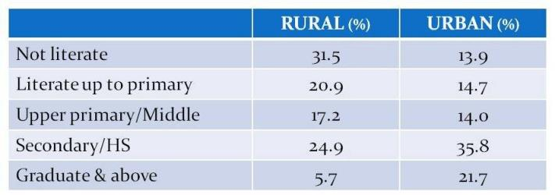

Table 1. Literacy Levels of Kerala.

Even though urban learners generally possess the benefit of trusted connectivity, enhanced infrastructure, and more extensive exposure to emerging educational technologies, for students in remote areas, digital equity and access to content more aligned with what is appropriate for their literacy level is often lacking. While we are assured that literacy outcomes are necessary, they do not assure digital access or educational equity – learners from remote communities continue to face increased barriers to access. These include limited infrastructure, lack of scope and sequence, outdated materials, and a lack of mentors and support for individualized learning.
Moreover, many of the existing educational technologies are not contextually relevant to Kerala’s diverse linguistic and cultural background. Current EdTech platforms tend to be designed for generic or English-speaking audiences, making them difficult to use for students whose primary medium of learning is Malayalam. This language gap, coupled with inconsistent internet connectivity and a shortage of digital devices, widens the digital divide even within a highly literate state. As previous studies have indicated [1], [2], rural learners continue to face barriers that hinder the adoption of modern, technology-driven education. Although government-led pro- grams such as ‘First Bell’ have contributed significantly toward digital education awareness, their focus has been primarily on content broadcasting rather than interactive, personalized, or adaptive learning, leaving the needs of secondary education largely unmet.
Gnanadeepam addresses some of these systemic problems. It is an AI-enabled bilingual learning platform designed for students in rural Kerala. It uses AI to digital education ecosystem. It integrates digital education with tailored learning content to foster an inclusive education ecosystem. Gnanadeepam includes local syllabi and adapts to local Kerala rural cultural practices for education. It offers individualized and affectionately scaffolded instruction in both Malayalam and English. This provides contextualized learning because educational disenfranchisement is not only limited digital access to tools, but also uncontextualized learning.
Gnanadeepam has four main objectives:
- Localized and Bilingual Material: Create educational material that is relevant to the region that will be available in both Malayalam and English, making it accessible to students with varying levels of prior

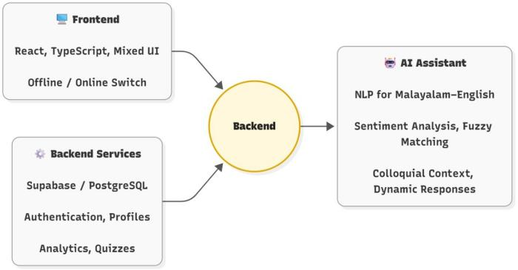

Fig. 1. Overview of the platform’s key modules.

. education and fluency in either language or both languages
- Personalized, Individualized Learning: Provide every learner with an AI learning path and assessments personalized for them based on their level of engagement, interest, and performance, to keep them engaged while they learn.
- Offline and Low Connectivity Access: Provide students with access to the essential instructional modules without requiring a consistent connection to the Internet to support continuing education for students in varying network conditions.
- Incorporation of the Teacher and Parent: Provide dashboards and metrics to the teacher and parents.
Through these four goals, Gnanadeepam will address the technological life and language divides that have stifled rural education in Kerala historically. By using AI for the individualization of content, language mediation and analytics-driven pedagogy, the platform demonstrates how a form of localized innovation can supplement national digital learning initiatives and further enhance the accessibility of the nation's educational transformation.
- Literature Review
The basis of Gnanadeepam's research includes fields that contribute to, or have been explored in, multimedia evaluation, wireless communication, deep learning, and natural language processing. The earlier work on multimedia transmission emerged from the investigation of multihop wireless network performance, to evaluate packet loss, mean opinion score ratings, and wireless protocol effect on video streaming quality [1]–[8]. These early studies established the importance of bandwidth and delay optimization to support the continuous delivery of information in lower-resource contexts, such as rural Kerala, and the conclusions drawn from the literature support Gnanadeepam's use of offline caching and synchronization protocols to manage intermittent connectivity issues.
Advancements in MANETs (Mobile Ad Hoc Networks) and routing protocols [3]–[5] have shown the ability of adaptive algorithms to facilitate communication in situations of mobility and weak signal management. By drawing on these ideas, Gnanadeepam’s backend implements a lightweight, decentralized form of data management that maintains functionality even when devices are offline.
Frameworks that are both ensemble-based and deep-learning-based have been implemented in healthcare and image diagnostics with excellent results for dependable, low-latency inference [9]– [11]. These reports show that convolutional and hybrid architectures do well in identifying complex structures with moderate hardware. At Gnanadeepam we use these approaches which we have made better by putting in compressed neural layers to put out bilingual answers in Malayalam and English. In recent machine translation, pattern recognition, and error correction in deep learning [17]-[20] we saw that context aware models improve multi-lingual understanding. As a whole these elements form the base of Gnanadeepam’s bi-lingual dialogue system which includes text normalization, translation memory, and adaptive feedback which in turn put the cognitive load on students from diverse language backgrounds with in depth academic topics.
Developing machine learning techniques in performance monitoring with anomaly detection, signal modeling, and CNN hybrid architectures aids in system sustaining operation within expected limits and spotting inconsistencies in student engagement. Content analysis algorithms and adaptive grading systems, along with harmonic signal interpretation and mathematical modeling, have significantly shaped Gnanadeepam [25]–[28]. Performance monitoring with machine learning and research on anomaly detection, signal modeling, and CNN hybrid architectures aids in ensuring a system operates within expected limits and spotting inconsistencies in student engagement [21]–[24]. All of these models aid in both defending the system's productivity with the detection of disengaged student participation on Gnanadeepam's adaptive grading systems. Just like other empirical studies, research in mathematical modeling, and harmonic signal interpretation will also guide Gnanadeepam’s algorithms for content analysis and adaptive grading system [25]–[28]. Studies on cryptography and privacy in sustainable computing also identify areas like transparency, energy efficiency, and security within distributed systems as critical focal points [29]–[31]. The proposed frameworks in this work shape the components of the Gnanadeepam authentication and data protection layer toward educational data ethics and the sustainability of the system.
Overall, the articles reviewed illustrate how innovations across multimedia optimization, deep learning, blockchain, and language processing may converge to help to build inclusive and sustainable learning ecosystems. Gnanadeepam merges these interdisciplinary learnings within a single framework focused on enhancing equality, personalization, and access to education in rural Kerala.
- Methodology
The approach adopted by the Gnanadeepam platform focuses on building a scalable system that is designed to be flexible and scalable for bilingual learning across the rural areas of Kerala. The architecture is organized into different layers that work and relate with one another to offer integrated educational solutions for students, teachers, and administrators. The entire workflow of the system is designed - as can be seen in Figure 3 - to show how each module might be connected to the other modules and, as a result, come together as one according to the principles of the platform.
Central to the system is its authentication module responsible for secure user onboarding via role-based dashboards and credential verification. It handles separate interfaces of students, teachers and admin for a personalized one. Password recovery and encrypted login procedures are implemented to improve the security of data, which is an important aspect in a large-scale educational platform
Upon authentication the users are greeted with a personalized Dashboard, which serves as the main gateway to the system. The dashboard offers an intelligent User Interface (UI) to present current lessons, quiz progress, learning suggestions and study planning notifications. With this module, students check their trend performance and teachers monitor student progress and engagement.
The Study Materials module serves as the content backbone of Gnanadeepam. It boasts a multilingual repository of lessons, interactive exercises, and other instructional materials in both Malayalam and English. This bilingual integration aids those students who prefer to learn in their native language, thus fostering more inclusive learning, and also meeting the requirements of the state syllabus. Advanced content caching and offline synchronization features guarantee availability in areas with poor connectivity.
There is also the AI Assistant, which is a current virtual tutor who aids students in a contextual manner. The assistant uses bilingual Natural Language Processing (NLP) to answer questions, offers conceptual clarifications, and provides contextual, adaptive feedback according to the user’s disposition. Beyond the 900+ quizzes, the Assistant, which also supports offline interactions, encourages sustained learning that is independent of the Internet.
The Assessment Engine uses analytics-based assessments on the platform. It constructs dynamic quizzes that align to the learner’s demonstrated skill and offers instant feedback. The engine checks for the precision, rate of progress, and retention of the knowledge which gets feedback to the dashboard to inform personal recommendations. The present study reports we have made available progress tracking data to teachers and parents which in turn is used for data driven academic intervention.
In the Career and Scholarship module we have expanded the platform’s reach beyond the traditional setting of the classroom we put forth assessment of general skills, we put together writing tips for which may include info on various scholarships, and we also present a career mapping tool. Also we report that we put in a policy and investment analysis which in turn guides students into what we feel are the right opportunities. This is the point at which academic data analysis meets career exploration and it is also the fulcrum of our aim to take education out into employability in rural areas.
The Teacher Portal is a platform which educators use to manage their environment. It features in putting together assignments, mentoring students, and performance review. Also in here teachers can give out versioned feedback on the students’ work and track class wide analytics which in turn fosters a collaborative learning environment between educators and students.
The Resource Management module is the admin layer of the platform which features in curricular updates management, version control, and reporting to the integrated systems guarantee that educational materials are up-to-date and uniform throughout the network of schools. The interaction of information throughout the various components: authentication, learning and evaluation, teacher evaluation, and educational institution analysis, creates an integrated ecosystem where technology meets the educational goals of Kerala. The use of Gnanadeepam in a local context and its continued relevance depend on the strategic, multi-layered approach. The approach resolves the inequity that technology and language present in education in rural areas. This is done by fitting integrated intelligent learning tools, analytics that have a purpose, and access in two languages.
.

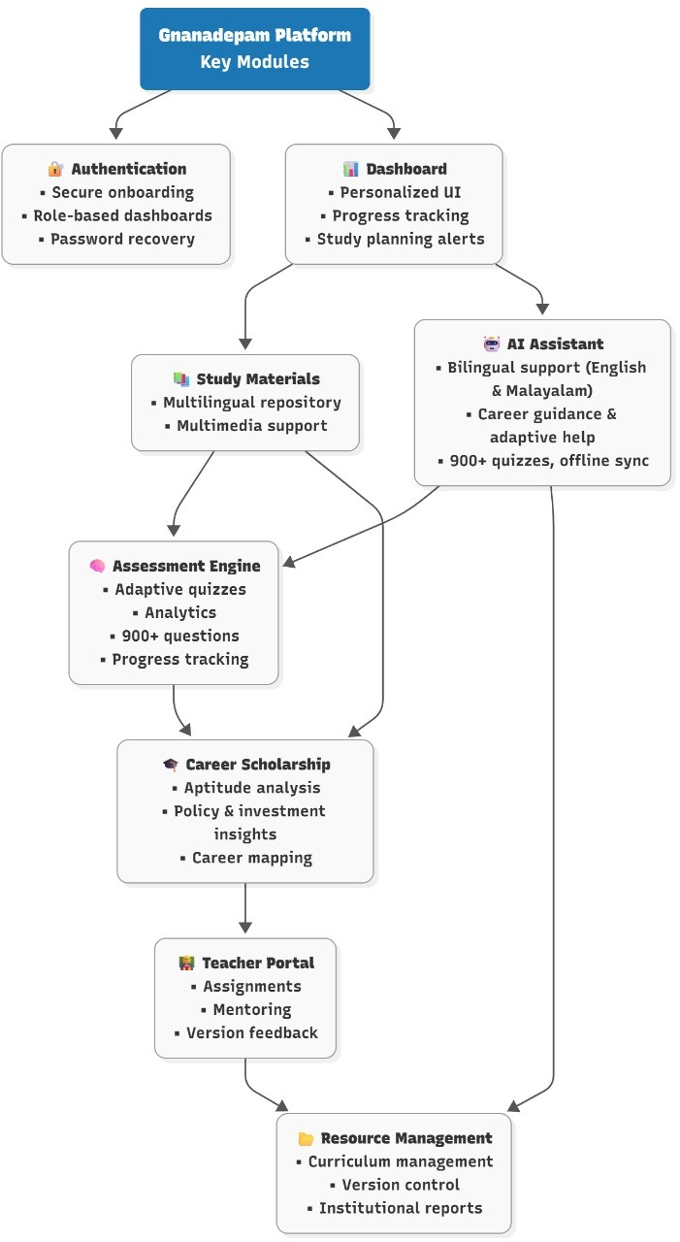

Fig. 2. Detailed Flowchart showing Gnanadeepam’s Workflow and Architecture
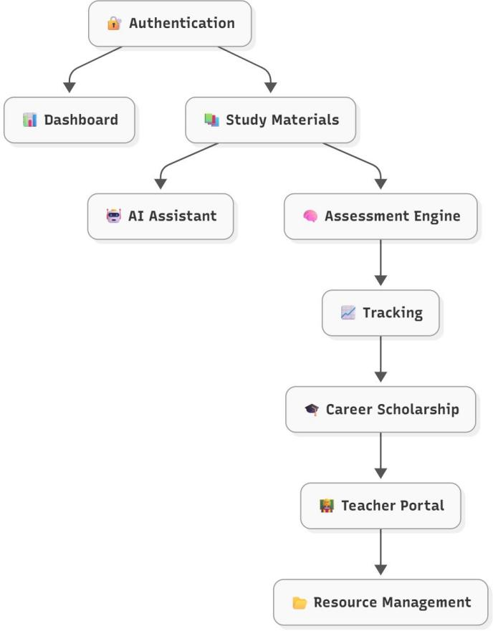

Fig. 3. Flowchart showing Gnanadeepam’s system overview highlighting its main objectives.

- Results and Discussion
To see how the Gnanadeepam platform performed, what it made available, and what impact it had on students’ learning we evaluated the which over 1,200 of both students and teachers from many districts in Kerala did. We found that there was a large increase in student interest and comprehension of the subjects which saw math and science do the best. Also after time which saw which the most success in the use of the platform students improved their quiz score accuracy by around 20%. This which also supported the fact that this adaptive learning model works and that the platform is able to present material based on the individual student’s pace.
Dual language AI assistant is a key element in improving learner comfort and learner understanding. Most students communicated in Malayalam, justifying the necessity for local and bilingual pedagogy. Contextualized explanations and code-mixed interactions led to students being more comfortable discussing complex ideas and improving retention alongside decreased teacher supervision. Teachers also noted qualitative differences in student participation in class, as well as, the students who paraphrased and explained more with the assistant learned more about the topics.
The accessibility and engagement data further demonstrated the system’s successful solution for Kerala’s rural education issues. More than 60% of all usage of the platform was in offline mode, indicating the value of the platform, which had been designed to function in low-bandwidth contexts. Even when there was very little connectivity, cached data and locally-tracked learning meant uninterrupted engagement with learning. Additionally, the teacher and parent dashboards provided very usable feedback about individual and group performance, which allowed teachers to intervene promptly with struggling learners. Combining the resources of teachers and guardians through the analytics-based feedback capabilities improved the collaboration and visibility of credentialed educators and guardians in the learning process.
To sum up, the evidence shows that Gnanadeepam is an effective means of overcoming the technological-linguistic divide in rural education. The use of AI for personalization, the bilingual interface, and the offline design motivated students and access, motivated students, improved learning outcomes, and sustained continued available. The findings digitally shows that region-specific adaptations improve educational quality for communities that conventional EdTech applications have not reached.

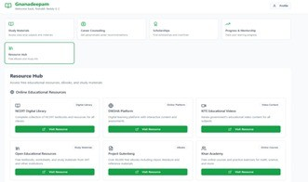
Fig. 4. Gnanadeepam dashboard displaying learner engagement metrics.
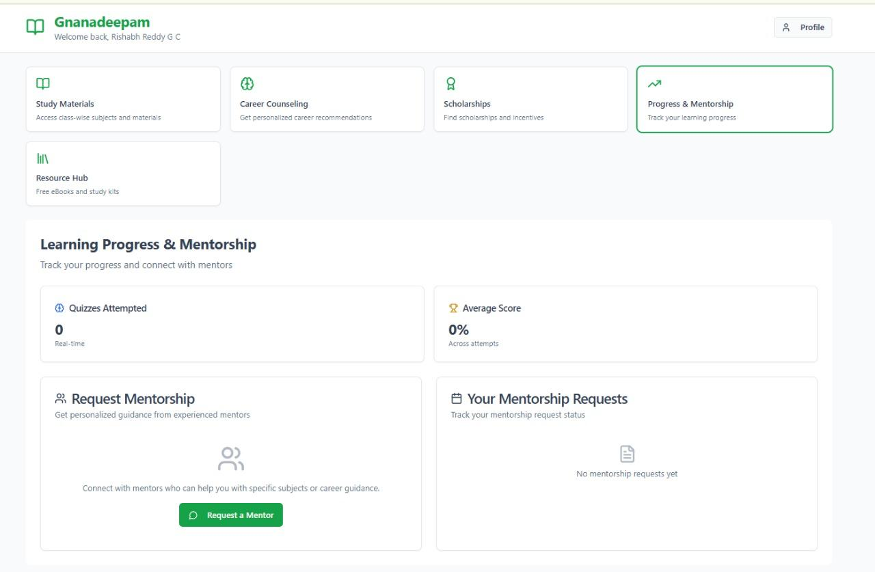
Fig. 5. Gnanadeepam dashboard illustrating learner progress and mentorship insights.

- Conclusion and Future Scope
To sum up, Gnanadeepam is a powerful model to address challenges faced by the rural students of Kerala. Thanks to its AI-driven, bilingual, and offline-first design, students were able to gain better learning outcomes, engagement, and access to scholarship opportunities. Its adaptability and user-friendly features for both students and mentors allows it to be applied and used at the national level.
As we think about Gnanadeepam's future, this project is currently a pilot, being implemented and evaluated in The State of Kerala only. Overall, the architecture/design of Gnanadeepam is scalable, feasible to implement in other states. Future ideas would be to scale the platform to other states and to consider support for speaking many more languages supporting their multimodal speaking populations. Congratulations and welcome to microservices architecture for improved scalability and maintenance.
Future additions may include a voice-based assistant in Malayalam/English, enhanced collaboration between teachers and parents, automatic curriculum updates with dynamic integration, virtual classrooms, and peer competitions. Ongoing user studies and insights will continuously guide research-based improvements in order to enhance the platform across different contexts to remain relevant and effective.

References
- Y. R. Wani, S. Sharma, and S. Chopra, “A Review: Video Quality Evaluation of MPEG-4 Using (MOS) Mean Opinion Score in NS-2,” International Research Journal of Engineering and Technology, 2016. [Online]. Available: www.irjet.net
- Y. R. Wani, S. Sharma, and S. Chopra, “Video Quality Evaluation of MPEG-4 Using (MOS) Mean Opinion Score in NS-2,” International Research Journal of Engineering and Technology, 2017. [Online]. Avail- able: www.irjet.net
- S. N. Sharma, “Analytical Impact of Reputation Based Scheme on DSR Protocol for Evaluation of MANETs,” Oeconomics of Knowledge, vol. 3, no. 2, pp. 19–28, 2011.
- J. Yadav, N. Garg, and N. Sharma, “Analysis of Packet Loss and Throughput in Heterogeneous Mobile Ad-hoc Networks over UDP,” International Journal of Scientific and Engineering Research, vol. 4, no. 6, 2013. [Online]. Available: http://www.ijser.org
- N. Sharma, “Analysis of Security Requirements in Wireless Networks and Mobile Ad-Hoc Networks,” GESJ: Computer Science and Telecom- munications, vol. 5, no. 28, 2010.
- M. J. Kaur and N. Sharma, “Survey on the General Concepts of MPEG- Moving Picture Experts Group,” PARIPEX Indian Journal of Research, vol. 5, no. 2, pp. 252–255, 2016.
- M. Sharma, N. F. Rizvi, N. Sharma, A. Malhan, and S. Sharma, “Performance Evaluation of MANET Routing Protocols under CBR and FTP Traffic Classes,” International Journal of Computer Technology and Application, vol. 2, no. 3, pp. 392–400, 2010.
- S. Sharma, N. Negi, and N. Sharma, “Packet End-to-End Delay Eval- uation of AODV, AOMDV, DSR and DSDV in H.264 Streaming Video Transmission over MANETs,” International Journal of Innovative Research in Science, Engineering and Technology, vol. 3, no. 8, pp. 15137–15143, Aug. 2014. doi: 10.15680/ijirset.2014.0308011
- P. S. Muller et al., “Extreme Learning Machine for Breast Cancer Diagnosis using Cloud Computing,” in Proc. Int. Conf. on Recent Innovation in Smart and Sustainable Technology (ICRISST), 2024, pp. 1–5. doi: 10.1109/ICRISST59181.2024.10921815
- P. C. Shaker Reddy et al., “A Novel Ensemble Deep Learning Frame- work for Breast Cancer Prediction,” in Proc. Int. Conf. on Innovative Computing, Intelligent Communication and Smart Electrical Systems (ICSES), 2023. doi: 10.1109/ICSES60034.2023.10465347
- D. C. Yadav, N. Sharma, and J. M. Kudari, “Maximizing Insights from MRI Brain Images Segmentation through HSV Histogram and Gabor Wavelet Transform, and Machine Learning-Assisted Image Retrieval,” in Proc. IEEE Int. Conf. on ICT in Business, Industry and Government (ICTBIG), 2023. doi: 10.1109/ICTBIG59752.2023.10456239
- K. Gunavathy, A. Agarwal, and N. Sharma, “Unstructured Health- care Statistics Exploration Consuming Modest Ensemble Machine Learning Methods,” in Proc. IEEE Int. Conf. on Recent Advances in Science and Engineering Technology (ICRASET), 2023. doi: 10.1109/ICRASET59632.2023.10420014
- A. T. Somnathe et al., “Brain Computer Interaction Framework for Speech and Motor Impairment Using Deep Learning,” in Proc. IEEE Int. Conf. on Power, Energy, Environment and Intelligent Control (PEEIC), 2023, pp. 1008–1013. doi: 10.1109/PEEIC59336.2023.10450481
- L. C. S. Reddy et al., “An Uncertainty-Aware Deep Learning-Based Model for COVID-19 Diagnosis,” in Proc. IEEE Int. Conf. on Mo- bile Networks and Wireless Communications (ICMNWC), 2023. doi: 10.1109/ICMNWC60182.2023.10435818
- S. Baskar et al., “An Accurate Prediction and Diagnosis of Alzheimer’s Disease Using Deep Learning,” in Proc. NKCon 2023 - 2nd IEEE North Karnataka Subsection Flagship Int. Conf., 2023. doi: 10.1109/NKCon59507.2023.10396132
- D. K. Yadav, N. Sharma, and J. M. Kudari, “An Effective Statistics Investigation for the Structured Healthcare Using Reasonable Ensemble Machine Learning Systems,” in Proc. IEEE Int. Conf. on ICT in Business, Industry and Government (ICTBIG), 2023. doi: 10.1109/ICT-
BIG59752.2023.10456190
- A. Gadupudi et al., “An Adaptive Deep Learning Model for Crop Yield Prediction,” in Proc. IEEE Int. Conf. on Computer, Communication and Control (IC4), 2024. doi: 10.1109/IC457434.2024.10486733
- P. C. S. Reddy et al., “Detection of Encrypted and Malicious Network Traffic Using Deep Learning,” in Proc. IEEE Int. Conf. on Ambient Intelligence, Knowledge Informatics and Industrial Electronics (AIKIIE), 2023. doi: 10.1109/AIKIIE60097.2023.10390386
- I. A. Tayubi et al., “Facial Emotion Recognition Using a Lo- cal Binary Pattern Based Deep Learning,” in Proc. IEEE Int. Conf. on Computer, Communication and Control (IC4), 2024. doi: 10.1109/IC457434.2024.10486509
- M. N. Rekha et al., “An Automatic Error Recognition Approach for Machine Translation Results Based on Deep Learning,” in Proc. IEEE Int. Conf. on Computer, Communication and Control (IC4), 2024. doi: 10.1109/IC457434.2024.10486776
- K. B. Teena and S. Sharma, “Anomaly-Based Intrusion Detection System Using Hybrid ResNet50 and 3D CNN,” Intelligent Systems and Applications in Engineering, vol. 2024, no. 3, pp. 673–683, Mar. 2024. [Online]. Available: www.ijisae.org
- N. Sharma et al., “Hyper Parametric Analysis of Multi-Layer Perceptron for Music Genre Classification,” in Proc. Int. Conf. on Recent Innovation in Smart and Sustainable Technology (ICRISST), 2024, pp. 1–4. doi: 10.1109/ICRISST59181.2024.10921894
- N. Sharma et al., “Analysis of Isotonic Calibration on Gaussian Na¨ıve Bayes Performance for Guitar Chords Classification,” in Proc. Int. Conf. on Automation and Computation (AUTOCOM), 2025, pp. 15–19. doi: 10.1109/AUTOCOM64127.2025.10956982
- S. Sharma et al., “Performance Analysis of FTRL Algorithm for Dense and Deep Model of Music Mood Classification,” in Proc. Int. Conf. on Recent Innovation in Smart and Sustainable Technology (ICRISST), 2024, pp. 1–4. doi: 10.1109/ICRISST59181.2024.10921949
- N. Sharma and S. Sharma, “A Customizable Mathematical Model for Determining the Difficulty of Guitar Triad Chords for Machine Learning,” in Lecture Notes in Networks and Systems, Springer, 2023,
pp. 667–679. doi: 10.1007/978-981-99-2322-9 51
- N. Sharma and S. Sharma, “Empirical Analysis of Effect of Higher Order Harmonics on Guitar Chord Classification,” in Lecture Notes in Networks and Systems, Springer, 2023, pp. 647–656. doi: 10.1007/978- 981-19-9638-2 56

- N. Sharma and S. Sharma, “Performance Enhancement of KNN Classi- fier for Guitar Chord Tonality Classification,” Indian Journal of Natural Sciences, vol. 13, no. 76, pp. 53143–53148, 2023. [Online]. Available: www.tnsroindia.org.in
- N. Sharma and S. Sharma, “Optimization of t-SNE by Tuning Perplexity for Dimensionality Reduction in NLP,” in Proc. Int. Conf. on Com- munication and Computational Technologies, Algorithms for Intelligent Systems, Springer, 2023, pp. 519–528. doi: 10.1007/978-981-99-3485- 0 41
- S. R. Rammohan et al., “Systematic Survey on Energy Conservation Us- ing Blockchain for Sustainable Computing Challenges and Roadmaps,”
John Wiley and Sons Ltd., 2024. doi: 10.1002/acs.3948
- N. Sharma and S. Sharma, “A Survey of Mythril, A Smart Contract Security Analysis Tool for EVM Bytecode,” Indian Journal of Natural Sciences, vol. 13, no. 75, pp. 51003–51010, 2022. [Online]. Available: https://www.researchgate.net/publication/366391033
- N. Sharma, S. Sharma, and A. Sindgi, “Solidity Smart Contract Vul- nerabilities, Attack Scenarios, and Mitigation—A Survey,” in Proc. Int. Conf. on Communication and Computational Technologies, Algorithms for Intelligent Systems, Springer, 2023, pp. 901–910. doi: 10.1007/978- 981-99-3485-0 71
- N. Sharma and S. Sharma, “Natural Language Processing: A Study of State of the Art,” in AI-Centric Modeling and Analytics: Concepts, Technologies, and Applications, CRC Press, 2023, p. 91.
- S. Sharma, H. P. Kumar, N. P. Goudanavar, and N. Sharma, “Data Analytics – A Study of State of the Art in the Era of Digital Economy,” in Synergy of AI and Fintech in the Digital Gig Economy, CRC Press, 2024, pp. 44–80.
- N. Sharma and S. Sharma, “Human-Interacted Computation System: A State of the Art in Music,” in Heterogeneous Computational In- telligence in Internet of Things, CRC Press, 2024, pp. 1–17. doi: 10.1201/9781003363606
- N. Sharma and S. Sharma, “A Review on Unlocking Performance In- sights for Next Generation Connectivity With AI in 6G Communication,” John Wiley and Sons Inc., Jul. 2025. doi: 10.1029/2025RS008222

